**Code Match**

**Documentation**

Riley Drishinski

Dayna Larm

Hannah Small

**User Documentation Table of Contents**

Software Specifications 3

How to Load Files Into the Database 4

How to Empty The Database 6

How to Check Codebase Information 7

How to Select Your Comparison and Run 8

How to Send The Information to Excel 9

Code Documentation Table of Contents 10

# Software Specifications

Operating System: We used windows 10/11. We doubt anything will be an issue if you use linux or mac.

Python Version: [3.11](https://www.python.org/downloads/) recommended, 3.8 has issues with some methods called in our comparators.

Python Packages: Be sure to install the python package mysql-connector and [mysql-connector-python](https://www.w3schools.com/python/python_mysql_getstarted.asp). Also be sure to install openpyxl and pandas(if you don’t have an IDE to do it for you, you might have to use pip3 instead of pip when installing openpyxl).

Python IDE: Feel free to use whichever one you want, we all used different ones and it worked fine. Some “errors” might show up at the top of some files. They are fine and won’t stop you from running the program.

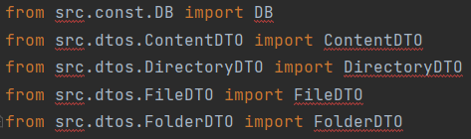

Example of errors that shouldn’t give you any trouble if you even see them at all.

SQL/MySQL Workbech Version: 8.0.27 and up

MySQL Code to Run: You can find the code to run in your MySQL workbench in the res folder. It is called database-setup.sql.

# How to Load Files Into the Database

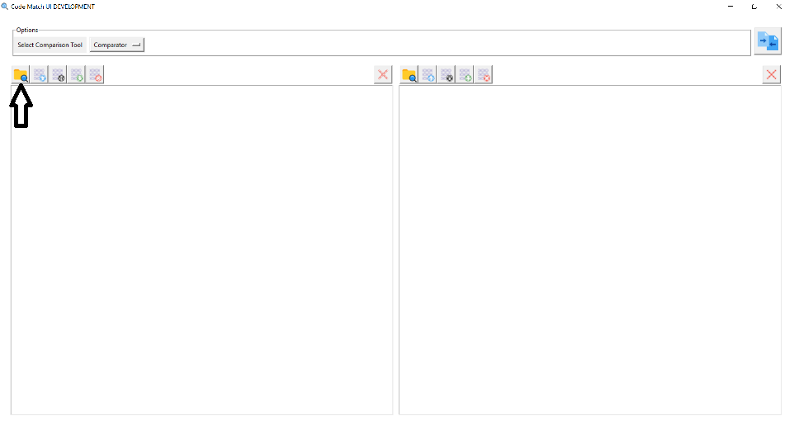

To load your files into the database that you hopefully know how to start, you first have to click the first button which is shaped like a folder.

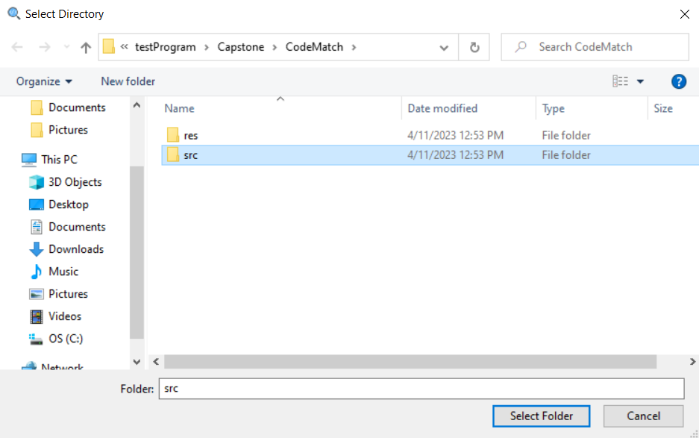

A window will pop up asking which folder of files you want to upload. Pick whichever folder that may be in whatever part of your pc.

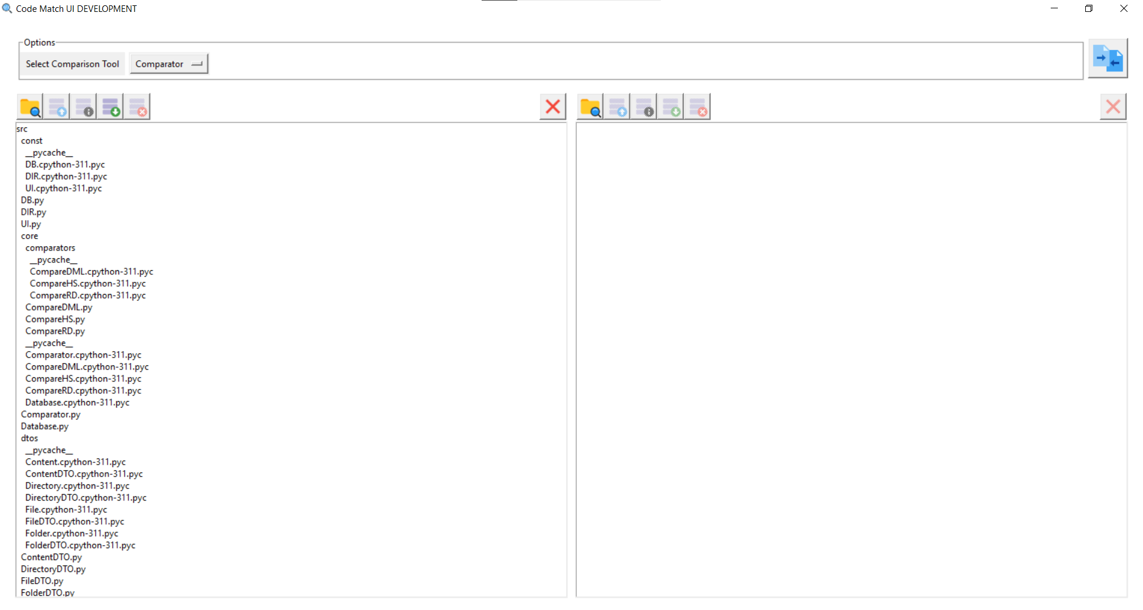

Your window should fill up with all of the files in the folder you selected. The other directory on the right side is filled the same way using the buttons above its view.

As of this version, the other buttons don’t do anything but we put them in for whoever takes the project next. The functions of these buttons in order after the file shaped folder were intended to be, upload to database, check information about the database, save the database, and delete the database.

# How to Empty The Database

If you accidentally select the wrong folders, you can easily delete them from the database/program. All you have to do it click the button with the large X on it. The same goes for the view on the right. If you want to delete the folders, just click the giant X on the far right side.

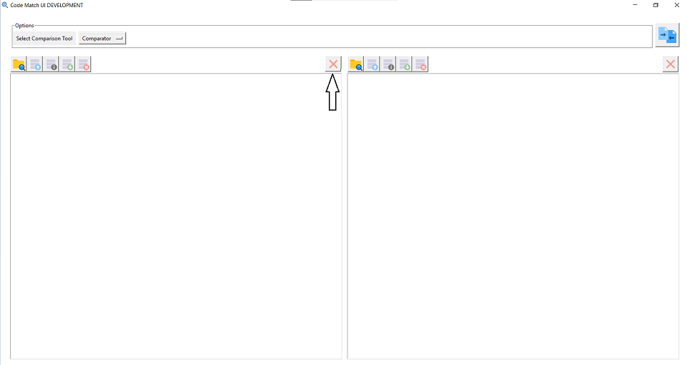

# 

# How to Check Codebase Information

Heres an example of what the information window is going to hopefully look like for whoever gets this next. This was made using the code that Professor Miller gave us that we will put in the folder for the lucky group reading this.

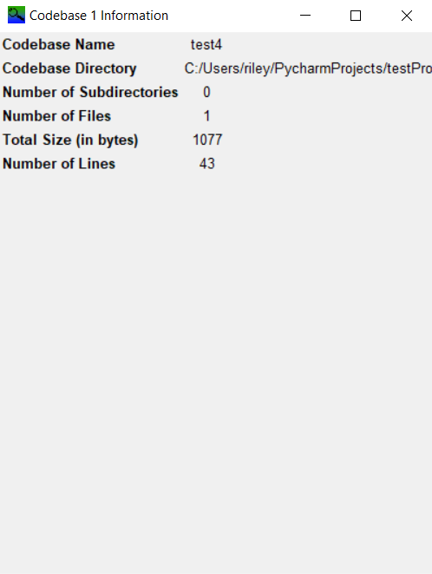

# How to Select Your Comparison and Run

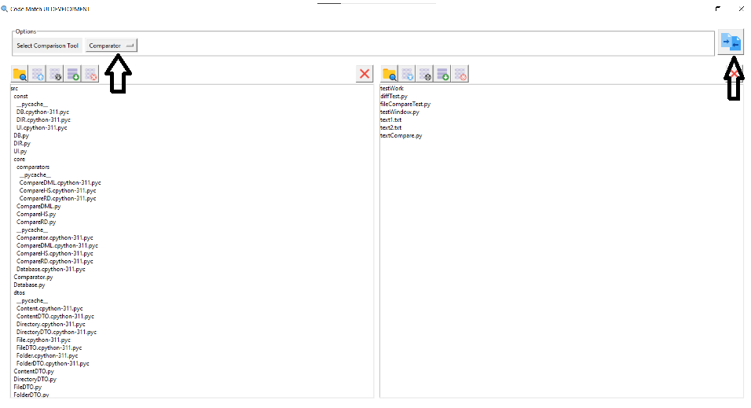

You have multiple choices for which comparison you want to pick. You have a default option that you can run straight away but you can also click the button next to select comparison tool to change comparators. After you make your selection, you click the file shaped button on the right.

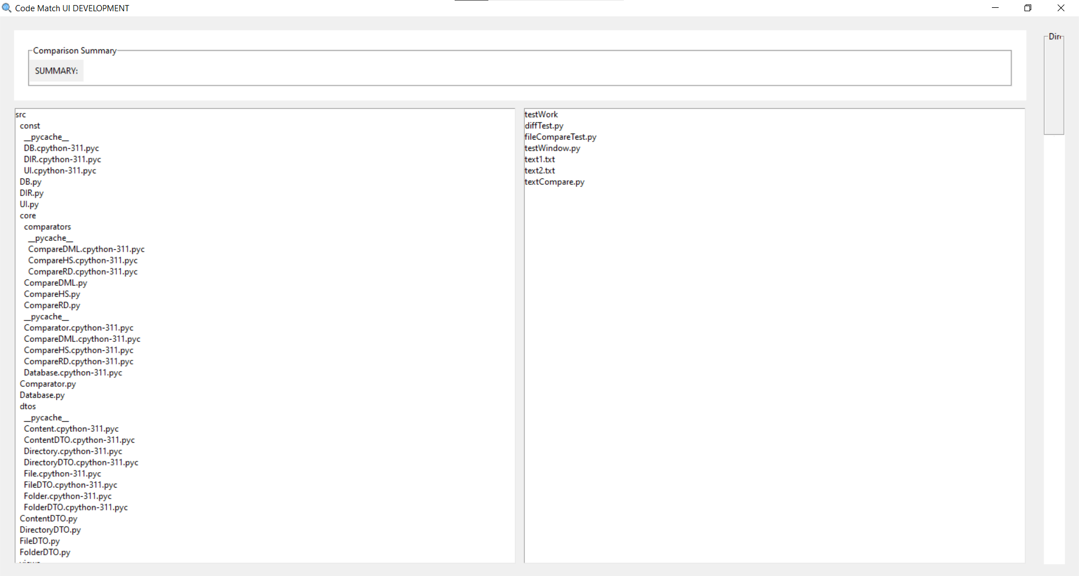

Your results will be displayed in a pop up window that, depending on the algorithm you chose, will display your results.

# How to Send The Information to Excel

If you want to send your comparator info to an excel table. All you need to do is run the comparator and click the export data button. It will ask you to name it and then you will be able to open it in excel.

# Code Documentation Table of Contents

Brief Description of Each Major File 10

Add your own comparison 12

# Brief Description of Each Major File

This is a brief description of each major file in the file comparison project. To get more in depth descriptions, you can go into the files themselves and see more explanations for how certain things are done.

CodeMatch.py

This file basically ties it all together. It has all of the different view files so that it all goes together in one nice window. It also has a few functions for some of the buttons as well such as the compare and open directory. If you want to add a comparison of your own you will have to follow the steps in the add your own comparison section.

DirectoryView.py

This section of the application deals with the database views, buttons such as the save, open and view database are also located here. The functions of these buttons are located in the Database file so if you have any issues with them, be sure to check their as well. DirectoryView is where you would want to add any buttons for database use.

MainWindow.py

Basically the holder of the directory views and the file content views as well. It has the compare options as well in a scroll down list so if you want to add your own, once again, follow the steps in the add your own comparison section.

Dtos

This is where we are storing different information about the SQL attributes, each file has values that are saved that make sense for what type of information it is with a few that are the same. An example is the fileDTO has all the information about the file itself, and folder has information about the folder the file is in. The file also has the folder ID so we know which folder it is in but most ID's are unique to each DTO. We have these DTOS so we can easily move data to and from the database.

Comparator.py

The main comparator file that all other comparator files are based off of and should override. We want to have this as the template so that anyone who wants to add their own comparators can follow this file and override the methods. The CompareDML/HS files are the files of our personal comparator codes that we found that follow this example.

Database.py

This is the file how everything is added to the database. All the functions are named as exactly what they do. The database itself is an SQL server that you need to have running in order for the program to work correctly, otherwise you won't be saving any information. You shouldn’t have to worry about changing any kind of passwords or users in sql as long as you run the sql code in database-setup.sql.

Constants

Where we keep all the constants for different parts of the program. DB has all of the database constants so that you can run the system more easily on any system. If you have any password issues with your SQL server, this might be a fix to your issue. DIR is for the directory and UI is for the user interface. We have these files for convienace so if you need a spot to have a constant choose one of these three, or make a new file if it doesn't fit in these.

# 

# Add your own comparison

1. You will want to make sure your comparison is able to pull lines out of the database. You can see example of how to do this in the comparator files we have made ourselves.
2. It will also have to be able to print out in the window that we create using ComparisonWindow.py. Once again, you can check our comparator files to see an example of how to do so.
3. Once you find that out you will have to add a case for it in the CodeMatch.py, you can see how to do that at around line 90. Keep track of the name you give it as you will need it for the next step.

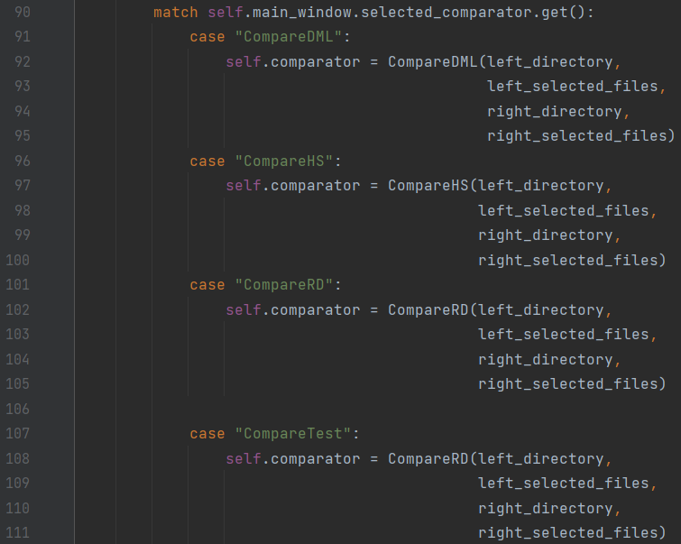

1. Either before or after you have finished the previous step, you will have to add the same name of whatever you called it to the list in MainWindow.py called available_comparators around line 46.

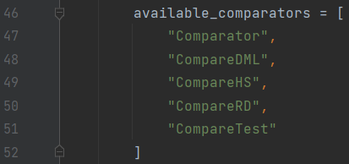

1. Test the program and you should see the option of selecting. If your comparison is set up right, you should be able to click the run button and have your code appear in the comparison pop up window.

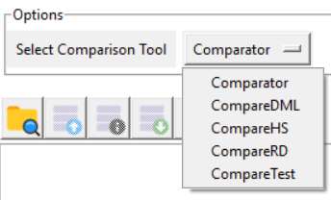

# 

# 

# 

Back to Top